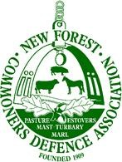

Verderers Court: Wednesday 14th April 2026
Good morning Official Verderer, Verderers, and members of the Court.
Andrew Parry-Norton chair of the CDA
2 x short presentments
Burning program
This year the weather conditions have proved difficult to complete the burning program but we acknowledge that FE have done a very good job. We, the CDA, would like to thank the Forestry England team and the head ecologist for completing as much as they did. As always it’s very much appreciated.
Perambulation Fencing
This is not a new subject but the serious problem still exists with very little or no progress ever made. The perambulation fencing in certain areas is in a very poor and dangerous condition. Stock and pigs easily walk through woefully inadequate fencing, a constant worry for Commoners.
This situation is not only a nuisance to other landowners but could have serious consequences for the stock and the public, especially gaining access near to busy roads.
We the CDA ask the Verderers again to contact all landowners responsible, and remind them of their legal liability and to persist if no remedial action is taken.

