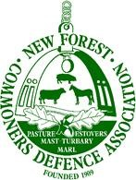

Verderers Court: **Wednesday 15th October** 2025

Presentment. Car parking revenue.

Good morning Official Verderer, Verderers, and members of the Court.

Andrew Parry-Norton CDA Chairman.

We, the CDA believe that all money raised through Forestry England’s new car parking charges should be reinvested directly into the New Forest itself.

Visitors and local residents who value and use this unique landscape are paying these charges; it is only fair that the funds support its protection, maintenance and sustainable management.

Spending this revenue elsewhere would undermine public trust and fail to recognize the New forest’s specific needs as a nationally important and environmentally sensitive area.

We ask the Verderers and Forestry England, that every penny raised here should stay here, to preserve this precious place for future generations.

Thank You.